SECOND SPIN SEWING STUDIO
Website Improvements – Part 2

Introduction
For Part 2 of the Second Spin Sewing Studio website, I improved the website that was created in Part 1. The main focus of the improvements was to make the website more visually appealing, consistent and responsive on different screen sizes.
I used an external CSS stylesheet to style all the pages and tried to maintain the original purpose and content of the website while improving its overall appearance and usability.
1. External CSS Stylesheet
One of the main improvements was creating and using an external stylesheet called styles.css.
The stylesheet is linked to all the HTML pages of the website. This helped me keep the design consistent because the same colours, fonts, buttons, spacing and other design elements could be reused across different pages.
I also used a CSS reset to remove unwanted default margins and padding and used box-sizing: border-box to make the sizing of elements easier to control.

2. Colour Scheme and Typography
I improved the overall appearance of the website by using a consistent colour scheme throughout the pages.
The main colours used are green, gold, cream and white. These colours were chosen to match the Second Spin Sewing Studio theme and create a natural and community-focused appearance.
I also used consistent font sizes, headings and paragraph styling to make the content easier to read.

3. Navigation
The navigation menu was improved and made consistent across all the pages.
The navigation contains links to:
- Home
- About Us
- Services & Workshops
- Mandela Day
- Enquiry
- Contact
Hover effects and active page styling were also added so that users can easily see which page they are currently viewing.

4. Page Layout
The layouts of the pages were improved using CSS Grid and Flexbox.
On larger screens, some sections use multiple columns so that the available screen space is used effectively. On smaller screens, these sections automatically change into simpler layouts.
Cards were also used to organise information such as services, workshops, community activities and ways of participating in the Mandela Day initiative.

5. Responsive Design
The website was made responsive so that it can be viewed on desktop, tablet and mobile devices.
Media queries were added to the external stylesheet to change the layout according to the size of the screen.
A breakpoint of 768px is used for tablet and smaller screens, while a breakpoint of 480px is used for mobile devices.
On smaller screens, content changes from multiple columns to fewer or single columns. The navigation also changes into a vertical layout on mobile devices.

6. Relative Units
Relative units such as rem and % were used in the CSS.
Using relative units allows elements such as text, containers and spacing to adapt better to different screen sizes instead of depending only on fixed pixel measurements.

7. Responsive Images
Images were improved so that they resize according to the available screen space.
Responsive image techniques such as <picture>, srcset and sizes were used where appropriate. CSS was also used to prevent images from becoming wider than their containers.
This helps the images display correctly on desktop, tablet and mobile screens.

8. Home Page Improvements
The Home page was improved by adding a clearer hero section and organising the content into different sections.
The page now provides a clearer introduction to Second Spin Sewing Studio, its services, sustainable fashion and the Mandela Day initiative.
Buttons were also styled consistently to make important links easier to identify.

9. About Us Page Improvements
The About Us page was improved by organising the information about the studio into clearer sections.
The mission, vision, sustainable fashion information and community focus are presented using structured layouts and cards.
The page also uses responsive images and layouts so that the information remains readable on smaller devices.

10. Services & Workshops Page Improvements
The Services & Workshops page was improved to clearly present the different services offered by Second Spin Sewing Studio.
The page includes information about repairs, alterations, upcycling and sewing workshops. Images and cards were used to separate the different types of information and make the page easier to navigate.

11. Mandela Day Page Improvements
The Mandela Day page was improved to make the 67 Minutes of Mend and Give Back initiative more noticeable.
The page includes images related to the Mandela Day initiative and provides information about donating, volunteering and giving back to the community.
The layout was also improved so that the Mandela Day content remains responsive on different devices.

12. Enquiry Page Improvements
The Enquiry page was improved by styling the form using the external stylesheet.
Form fields, labels, buttons, radio buttons and checkboxes were organised to make the form easier to understand and complete.
Focus styling was also added to form fields so that users can clearly see which field they are currently using.

13. Contact Page Improvements
The Contact page was improved by organising the contact information, opening hours and locations into separate sections.
Information about the Braamfontein Workshop Hub and Soweto Collection Point is included.
The location map was also kept on the page and made responsive so that it adjusts according to the size of the user's screen.

14. Testing
After making the improvements, I tested the website by opening each page and checking the navigation links, images, buttons, form, map and page layouts.
I also resized the browser to check how the website responds to different screen sizes.
All pages were checked to ensure that they remain usable and readable on desktop, tablet and mobile screen sizes.

15. Responsive Testing Evidence
The following screenshots show how the website adapts to different screen sizes.
Desktop View
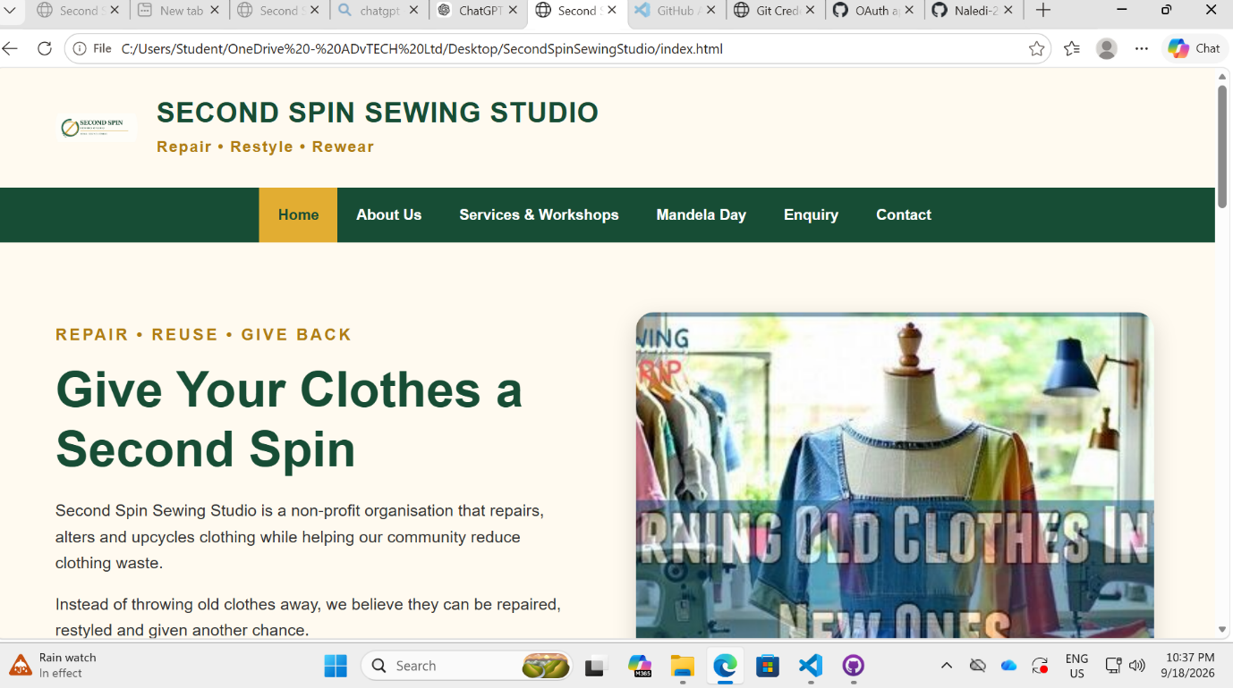
Tablet View
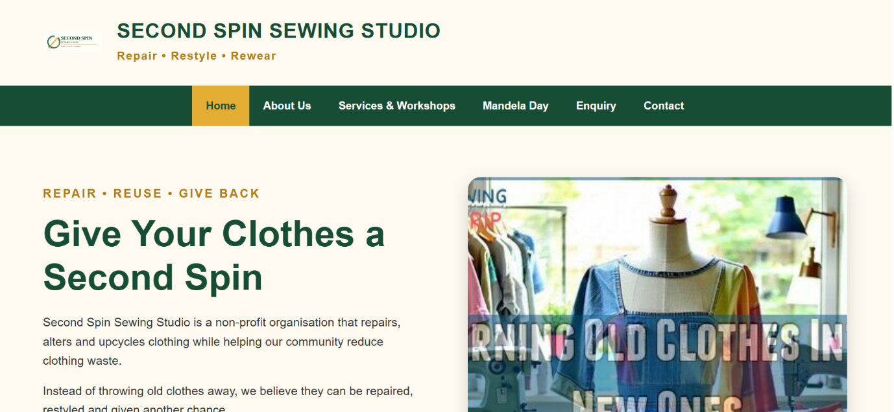
Mobile View
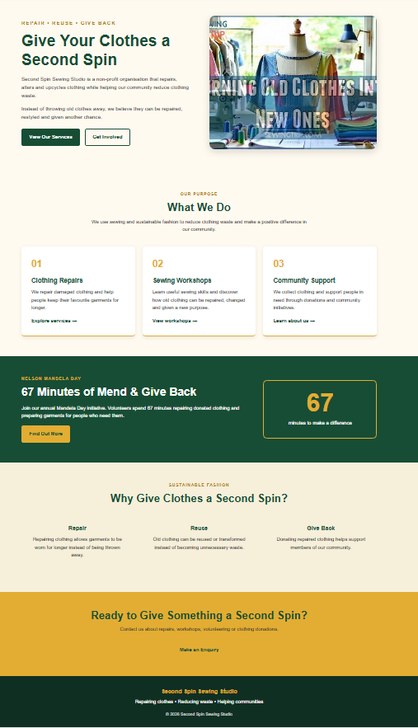

Conclusion
Part 2 improved the overall design and responsiveness of the Second Spin Sewing Studio website. The use of external CSS created a more consistent appearance across all the pages, while CSS Grid, Flexbox, media queries, relative units and responsive images helped the website adapt to different screen sizes.
The final website maintains the purpose and content of the original Part 1 website while improving its appearance, organisation and usability.

